Switching Regulator Series

Step-Down DC/DC Converter

BD9A100MUV Evaluation Board

BD9A100MUV-EVK-001

**Description**

This evaluation board has been developed for ROHM’s synchronous buck DC/DC converter customers evaluating BD9A100MUV. While accepting a power supply of 2.7-5.5V, an output of 1.8V can be produced. The IC has internal 60mΩ high-side N-channel MOSFET and 60mΩ low-side N-channel MOSFET and a synchronization frequency is of 1MHz. A Soft Start circuit prevents in-rush current during startup. An EN pin allows for simple ON/OFF control of the IC to reduce standby current consumption. A MODE pin allows the user to select fixed frequency PWM mode or enables the Deep-SLLM control and the mode is automatically switched between the Deep-SLLM control and fixed frequency PWM mode. Include OCP (Over Current Protection) and SCP (Short Circuit Protection).

**Evaluation Board Operating Limits and Absolute Maximum Ratings** (Ta=25℃)

|  |  |  |  |  |  |  |
| --- | --- | --- | --- | --- | --- | --- |
| Parameter | Symbol | Limit | | | Unit | Conditions |
| MIN | TYP | MAX |
| Supply Voltage | V­CC | 2.7 | - | 5.5 | V |  |
| Output Voltage / Current | VOUT | - | 1.8 | - | V |  |
| IOUT | - | - | 1 | A |  |

Evaluation Board

**Vout**

**GND**

**EN**

BD9673EFJ Eval Board

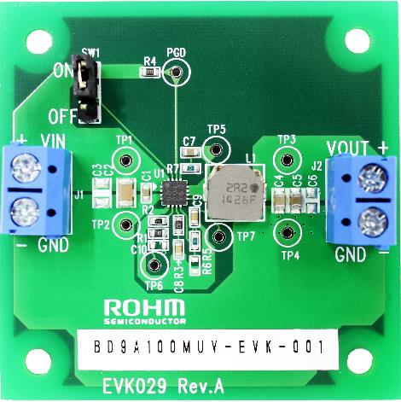

Figure 1. BD9A100MUV-EVK-001 Evaluation Board

**Operation Procedures**

1. Necessary equipments

(1) DC power-supply of 2.7V to 5.5V/1A

(2) Maximum 1A load

(3) DC voltmeter

2. Connecting the equipments

(1) DC power-supply presets to 5.0V and then the power output turns off.

(2) The max. load should be set at 1A and over it will be disabled.

(3) Check Jumper pin of SW1 is short, between intermediate-terminal and OFF-side terminal.

(4) Connect positive-terminal of power-supply to VIN+terminal and negative-terminal to GND-terminal with a pair of wires.

(5) Connect load’s positive-terminal to VOUT+terminal and negative-terminal to GND-terminal with a pair of wires.

(6) Connect positive-terminal of DC voltmeter 1 to TP1 and negative-terminal to TP2 for input-voltage measurement.

(7) Connect positive-terminal of DC voltmeter 2 to TP3 and negative-terminal to TP4 for output-voltage measurement.

(8) DC power-supply output is turned ON.

(9) IC is enable (EN) by shorting Jumper-pin of SW1 between intermediate-terminal and ON-side terminal.

(10) Check DC voltmeter 2 displays 1.8V.

(11) The load is enabled.

(12) Check at DC voltmeter 1 whether the voltage-drop (loss) is not caused by the wire’s resistance.

DC Voltmeter 2

+

-

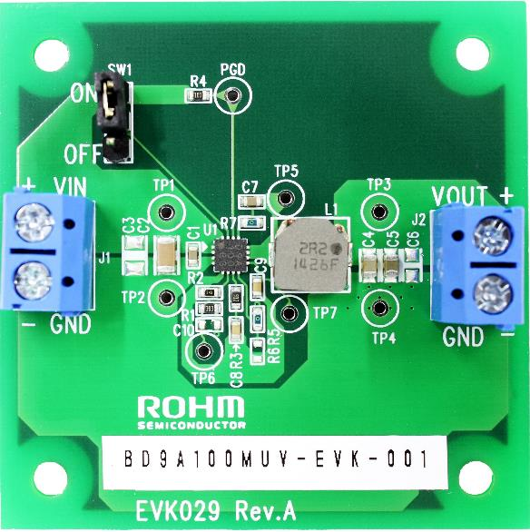

-

+

DC Voltmeter 1

+

DC Power

-

+

Load

-

Figure 2. Connection Diagram

**Enable-Pin**

To minimize current consumption during standby-mode and normal operation, Enable-mode can be switched by controlling EN pin(15pin) of the IC. Standby-mode is enabled by shorting Jumper-pin of SW1 between intermediate-terminal and OFF-side terminal and normal-mode operation by shorting between intermediate-terminal and ON-side terminal.

It also can be swithed between standby-mode and normal-mode operation by removing Jumper-pin and controlling the voltage between EN and GND-terminal. Standby-mode is enabled when the voltage of EN is under 0.5V, and normal-mode operation when it is over 2.0V.

**Cricuit Diagram**

VIN = 2.7V～5.5V, VOUT = 1.8V

1

P

V

I

N

1

5

E

N

1

6

A

V

I

N

5

A

G

N

D

R

3

C

8

S

W

1

O

N

O

F

F

C

1

C

2

C

3

T

P

1

V

I

N

G

N

D

S

W

1

2

C

7

T

P

5

L

1

C

4

C

5

C

6

T

P

3

V

O

U

T

G

N

D

F

B

6

R

2

R

1

C

1

0

U

1

B

D

9

A

1

0

0

M

U

V

I

T

H

7

T

P

2

R

7

T

P

6

T

P

4

2

P

V

I

N

3

P

G

N

D

4

P

G

N

D

S

W

1

1

S

W

1

0

S

S

9

C

9

T

P

7

J

1

J

2

B

O

O

T

1

3

1

4

P

G

D

P

G

D

R

4

8

M

O

D

E

R

5

R

6

1

7

Ｅ

Ｐ

Ａ

Ｄ

Figure 3. BD9A100MUV-EVK-001 Circuit Diagram

**Bill of Materials**



**Layout**

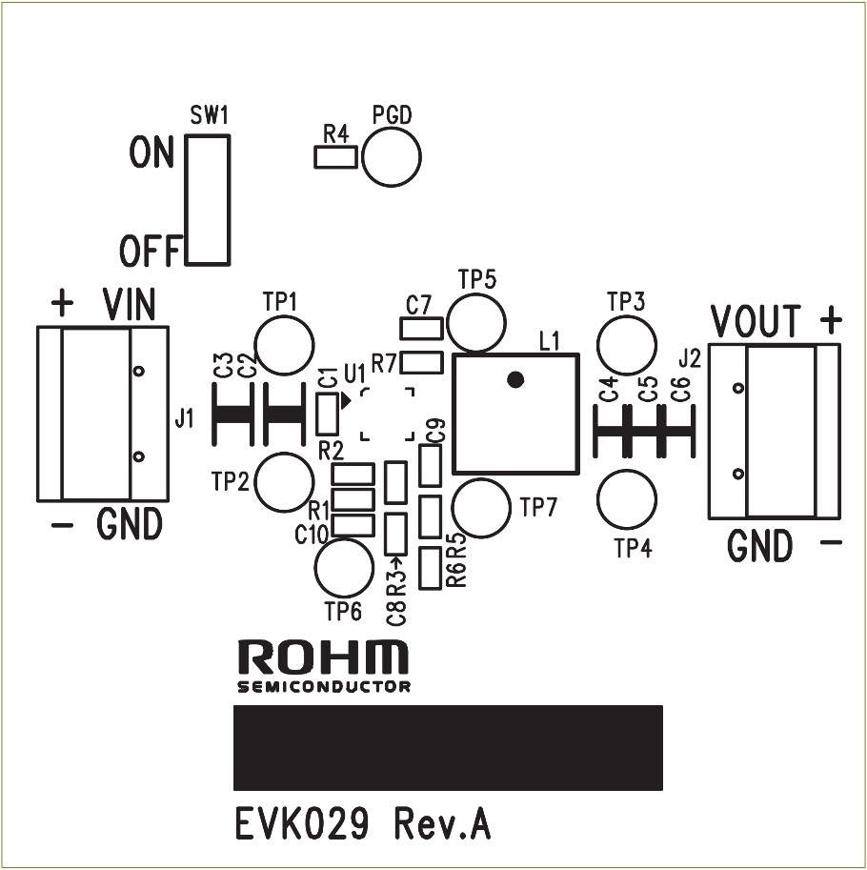

Figure 4. Top Silk Screen (Top view)

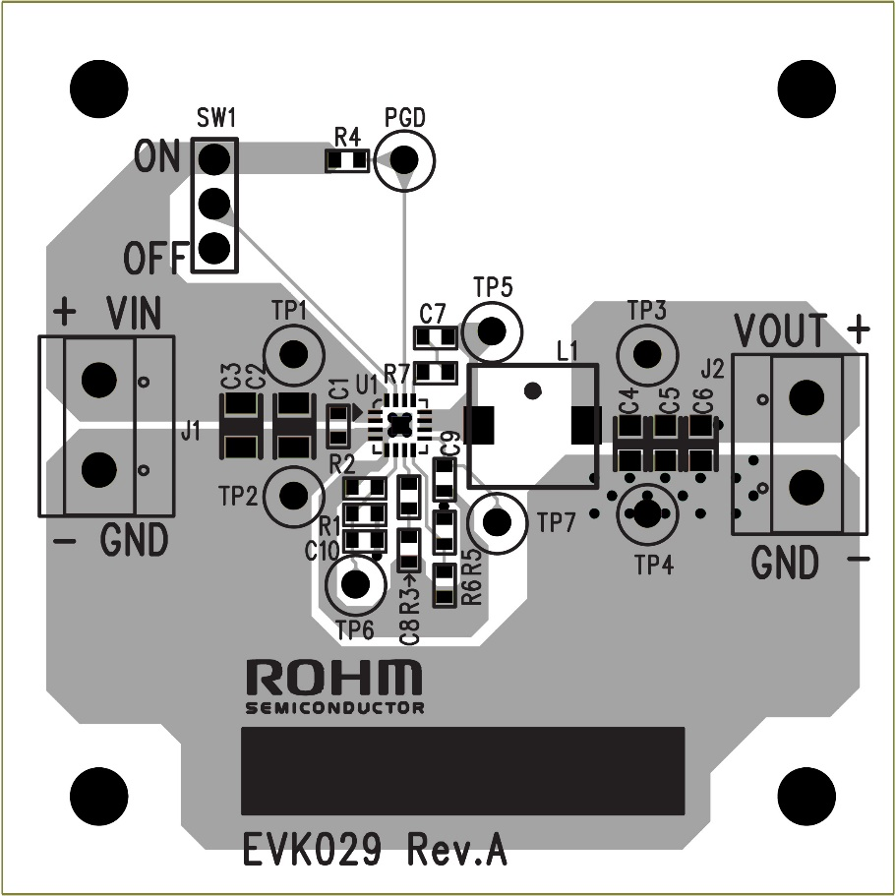

Figure 5. Top Silk Screen and Layout (Top view)

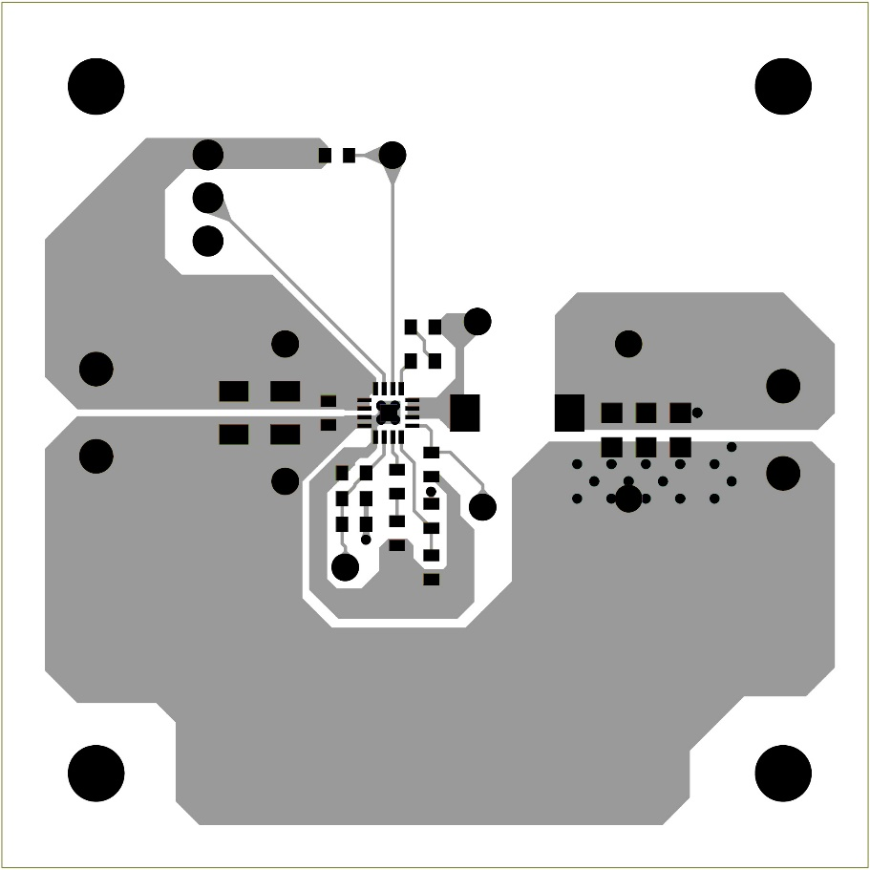

Figure 6. Top Side Layout (Top view)

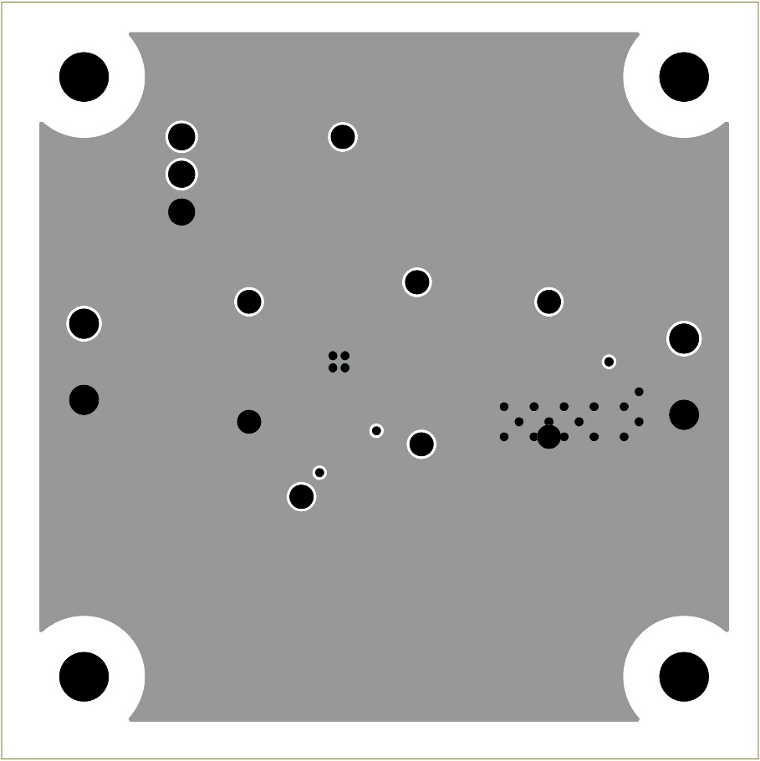

Figure 7. L2 Layout (Top view)

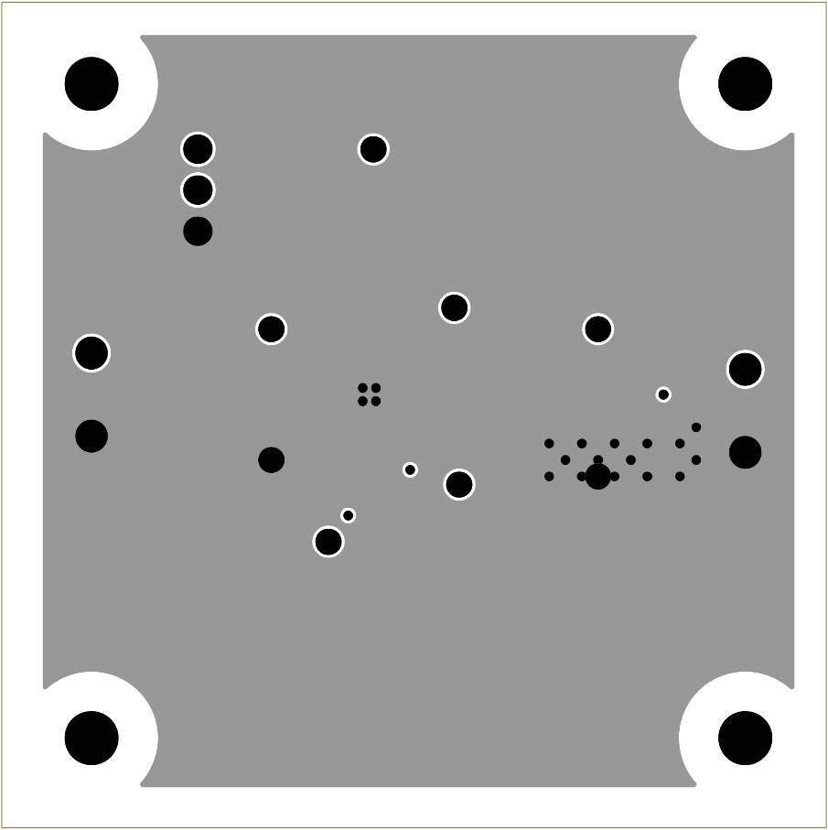

Figure 8. L3 Layout (Top view)

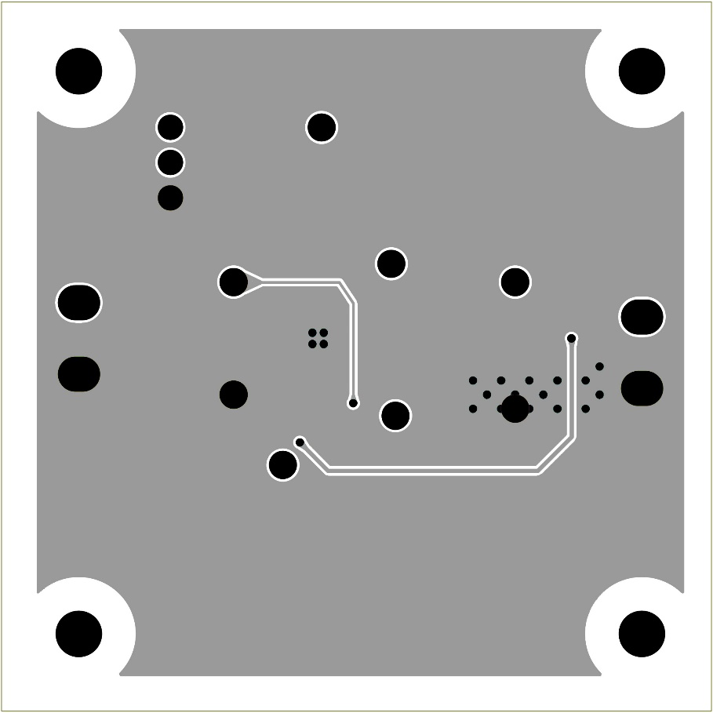

Figure 9. Bottom Side Layout (Top view)

Figure 10. Efficiency vs Load Current

Figure 11. Line Regulation

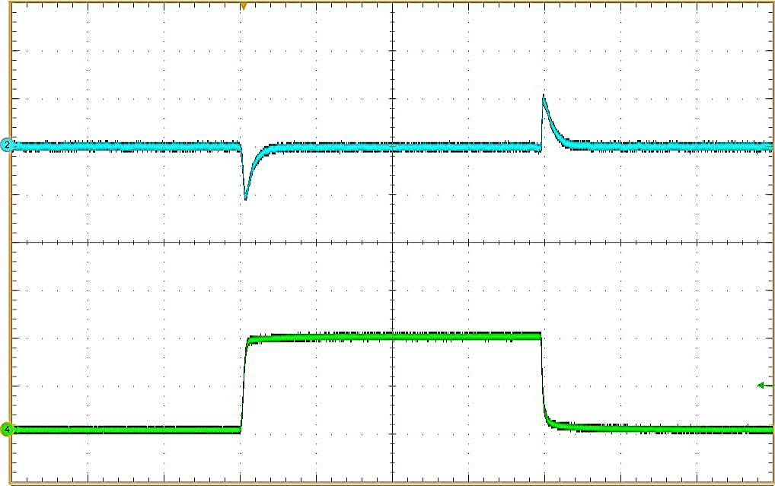

VIN = 5.0V

VO = 1.8V

VO (AC)

50mV/div

IO: 0A→1A→0A

IO: 0.5A/div

Time scale 1ms/div

Figure 13. Load Transient Characteristics

Figure 12. Load Regulation

Phase

Gain

Figure 14. Loop Response VIN = 5.0V, VO = 1.8V, IO = 1.0A

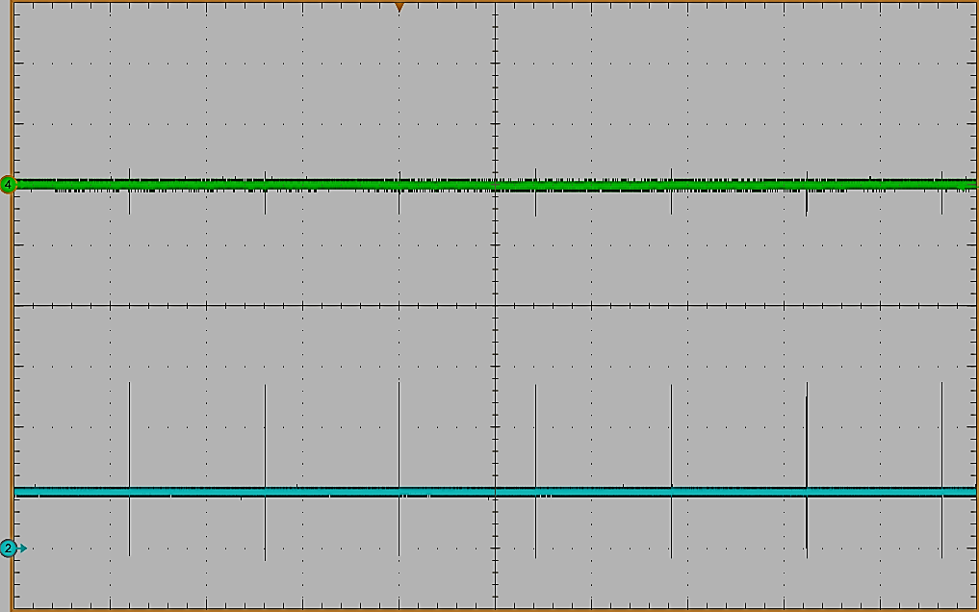

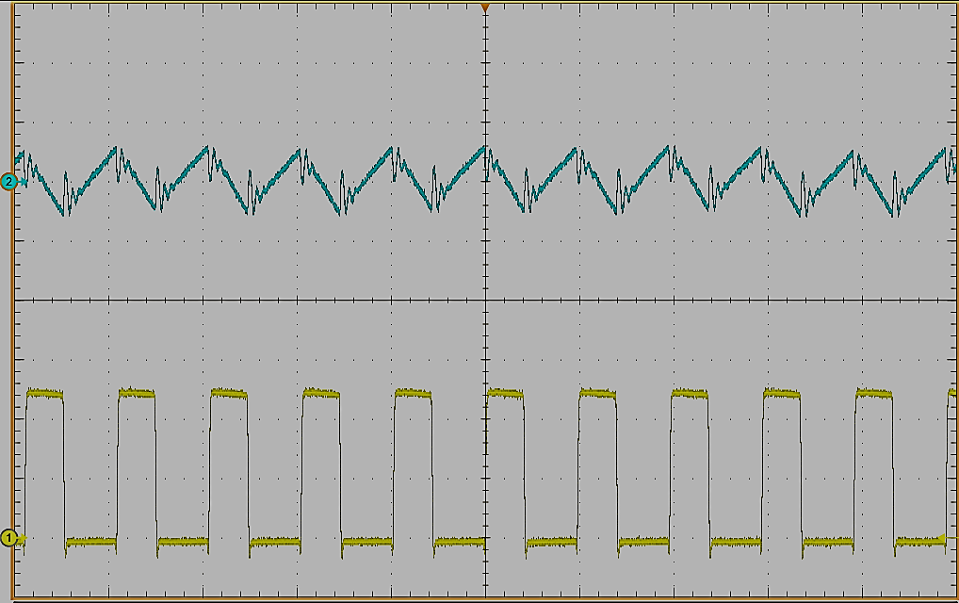

VIN (AC)

50mV/div

VIN (AC)

50mV/div

VSW

2V/div

VSW

2V/div

Time scale 1μs/div

Time scale 20ms/div

Figure 16. Input Voltage Ripple Wave

VIN = 5.0V, VO = 1.8V, IO=1A

Figure 15. Input Voltage Ripple Wave

VIN = 5.0V, VO = 1.8V, IO=0A

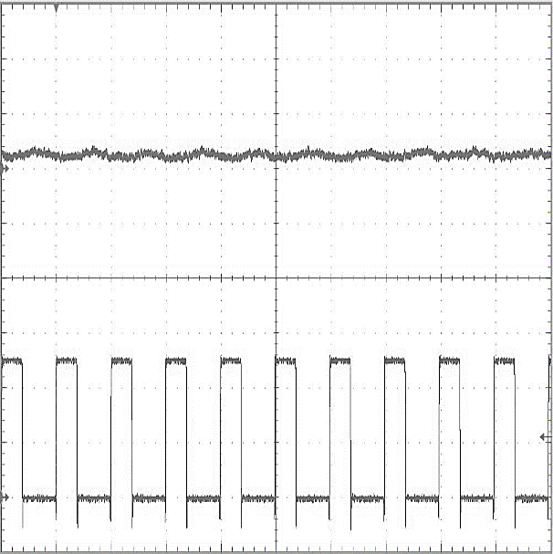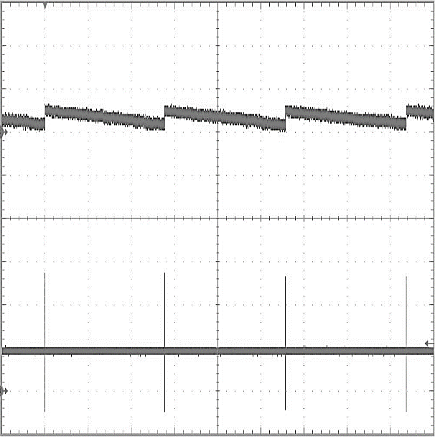

VO (AC)

20mV/div

VO (AC)

20mV/div

VSW

2V/div

VSW

2V/div

Time scale 1μs/div

Time scale 2ms/div

Figure 18. Output Voltage Ripple Wave

VIN = 5.0V, VO = 1.8V, IO=1A

Figure 17. Output Voltage Ripple Wave

VIN = 5.0V, VO = 1.8V, IO=0A

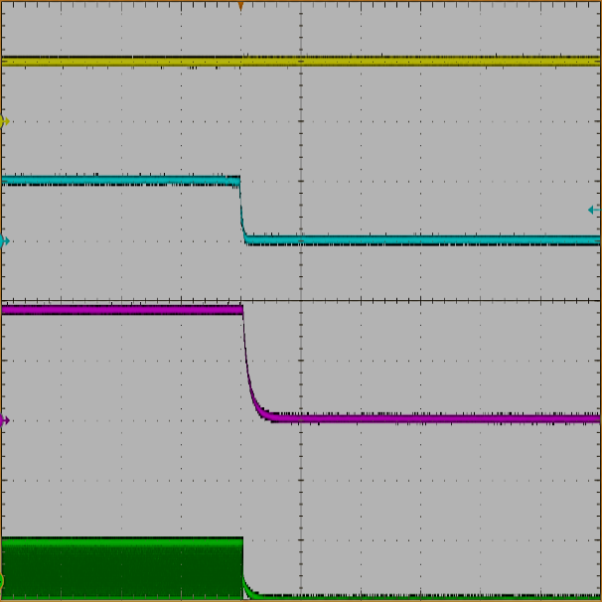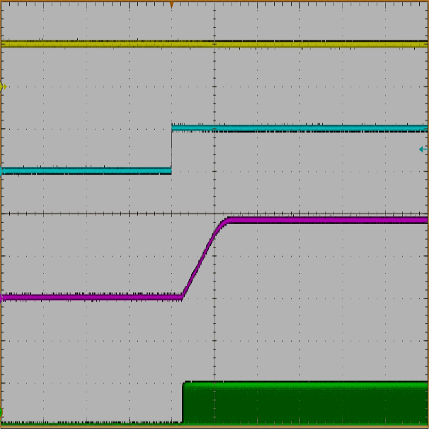

VIN

5V/div

EN

5V/div

VO

1V/div

VSW

5V/div

Time scale 1ms/div

Time scale 1ms/div

Figure 20. Power-down by EN

VIN = 5.0V, VO = 1.8V

Figure 19. Start-up by EN

VIN = 5.0V, VO = 1.8V